1. Provide link to GitHub repository for TAs to view the code. Code should include unit tests.(5 points)

<https://github.com/HughHoang/4353Group14>

2. Provide SQL statements to create database.(3 points)

CREATE DATABASE fuel;

CREATE TABLE UserCredentials (

id int(5) NOT NULL AUTO_INCREMENT,

username varchar(100) NOT NULL,

password varchar(255) NOT NULL,

PRIMARY KEY (id)

);

CREATE TABLE ClientInformation (

id int(5) NOT NULL,

fullName varchar(100) NOT NULL,

address_1 varchar(100) NOT NULL,

address_2 varchar(100),

state varchar(2) NOT NULL,

city varchar(50) NOT NULL,

zipcode int(5) NOT NULL,

Primary KEY (id),

FOREIGN KEY (id) REFERENCES UserCredentials(id)

);

CREATE TABLE FuelQuote (

orderID int (5) NOT NULL AUTO_INCREMENT,

userID int(5),

gallons double NOT NULL,

deliveryAdd varchar(200) NOT NULL,

deliveryDate date NOT NULL,

price double NOT NULL,

totalDue double NOT NULL,

Primary KEY (orderID),

FOREIGN KEY (userID) REFERENCES ClientInformation (id)

);

SQL statements also included in GitHub repo under sql/sql_statements.txt

3. Rerun the code coverage report and provide it. (2 points)

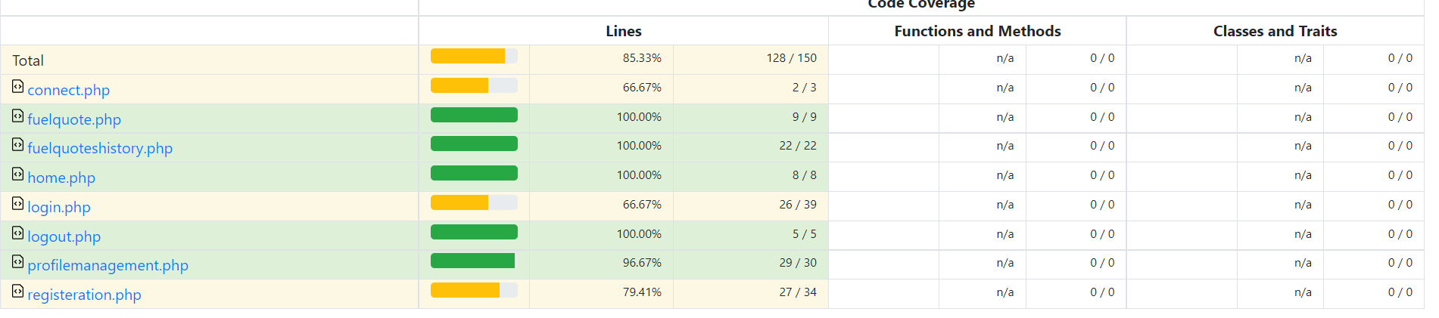

Included in the GitHub repo, under codecoverage/codecoveragehtml/htdocs/index.html

**4. IMPORTANT: list who did what within the group. TAs should be able to validate in GitHub, otherwise team members who didn't contribute will receive a ZERO.**

Fill in this table, provide as much details possible:

| Group Member Name | What is your contribution? | Discussion Notes |
| --- | --- | --- |
| Hugh Hoang | Wrote sql code |  |
| Julio Santos | Collaborated and added html code |  |
| Huan Huynh | Created and wrote php files and linked it with sql code to create database |  |